**Download and Install MySQL for Windows Steps**

Now, Let’ ‘s break down **MySQL**software downloading steps for a better understanding and see install MySQL on **Windows 10** step by step.

**Step 1: Visit the Official MySQL Website**

Open your preferred web browser and navigate to [the official MySQL website](https://dev.mysql.com/downloads/installer/). Now, Simple click on first download button.

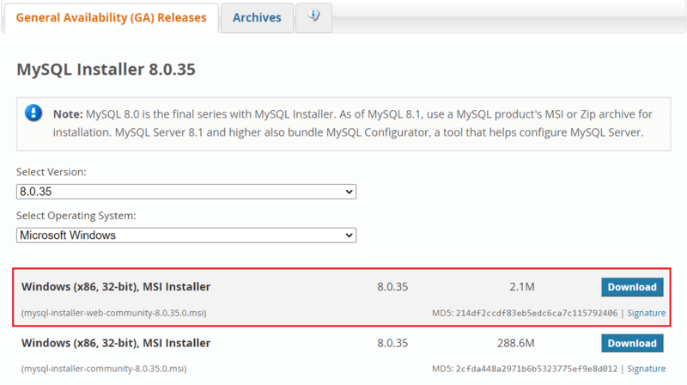

**Step 2: Go to the Downloads Section**

On the MySQL homepage, Click on the ” **No thanks, just start my download**” link to proceed MySql downloading.

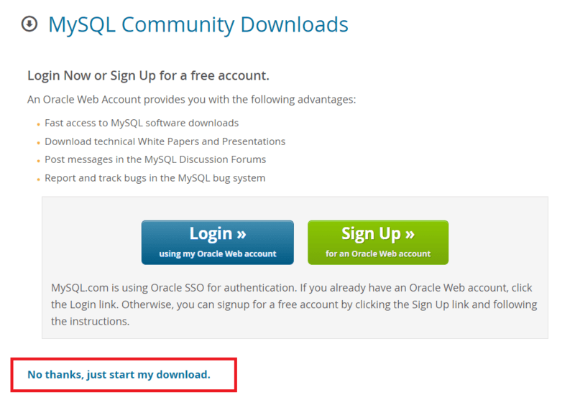

**Step 3: Run the Installer**

After MySQL downloading**MySQL.exe** file , go to your Downloads folder, find the file, and double-click to run the installer.

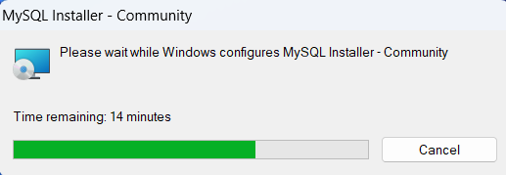

**Step 4: Choose Setup Type**

The installer will instruct you to choose the setup type. For most users, the “**Developer Defaul**t” is suitable. Click “Next” to proceed.

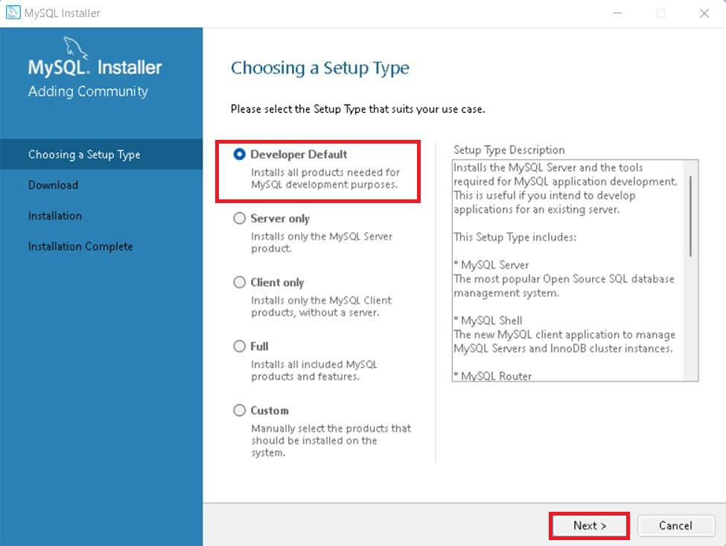

**Step 5: Check Requirements**

You might be prompted to install necessary MySQL [software](https://www.geeksforgeeks.org/software-and-its-types/), typically **Visual Code**. The installer can auto-resolve some issues, but not in this case.

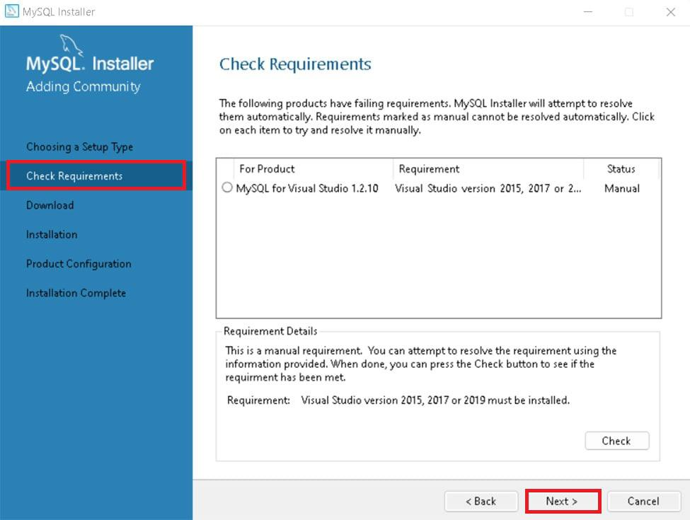

**Step 6: MySQL Downloading**

Now that you’re in the download section, click “Execute” to start downloading the components you selected. Wait a few minutes until all items show tick marks, indicating completion, before moving forward.

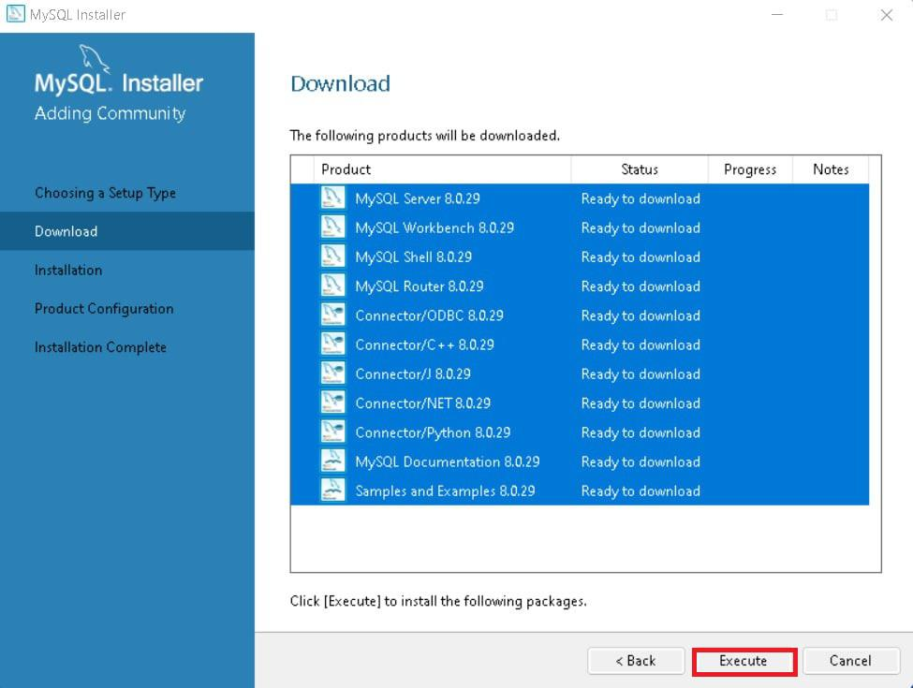

**Step 7: MySqL Installation**

Now the downloaded components will be installed. Click “**Execute**” to start the installation process. MySQL will be installed on your Windows system. Then click **Next**to proceed

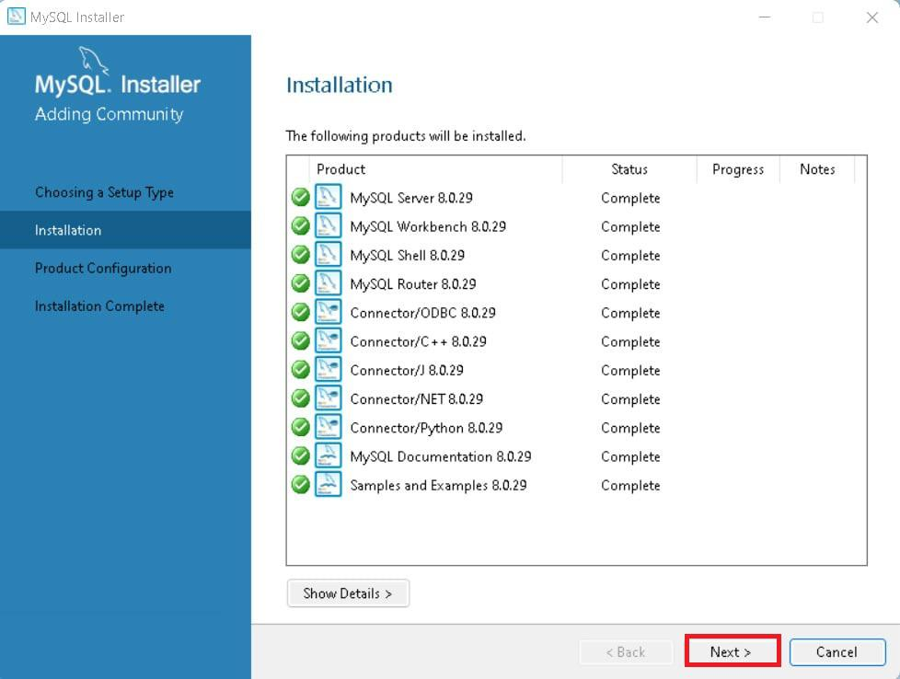

**Step 8: Navigate to Few Configuration Pages**

Proceed to “**Product Configuration**” > “**Type and Networking**” > “**Authentication Method**” Pages by clicking the “Next” button.

**Step 9: Create MySQL Accounts**

Create a password for the MySQL root user. Ensure it’s strong and memorable. Click “**Next**” to proceed.

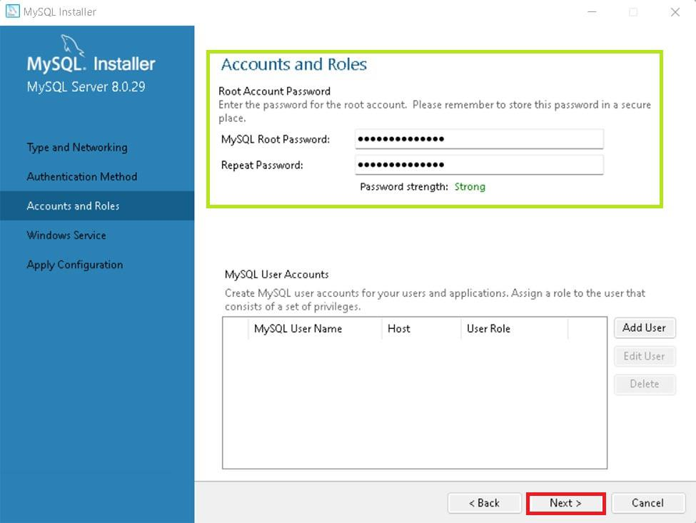

**Step 10: Connect To Server**

Enter the root password, click Check. If it says “Connection succeed,” you’ve successfully connected to the server.

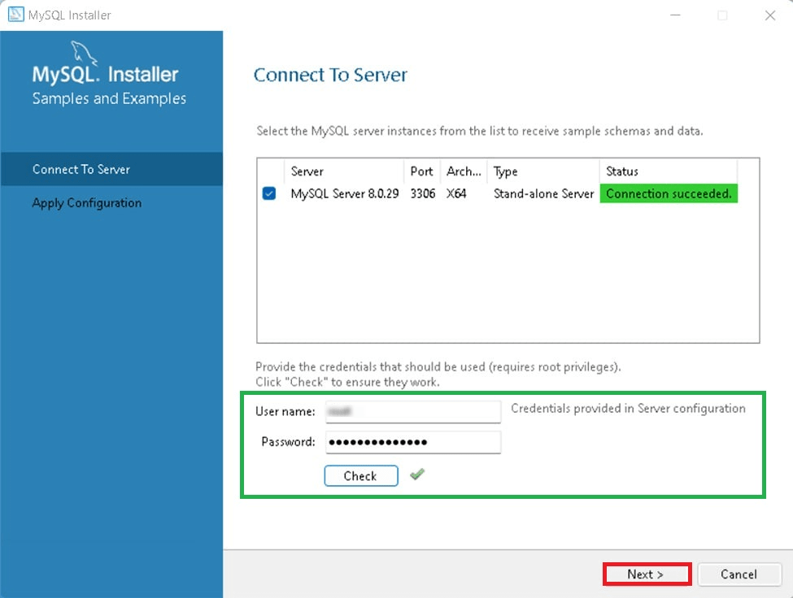

**Step 11: Complete Installation**

Once the installation is complete, click “Finish.” Congratulations! MySQL is now installed on your Windows system.

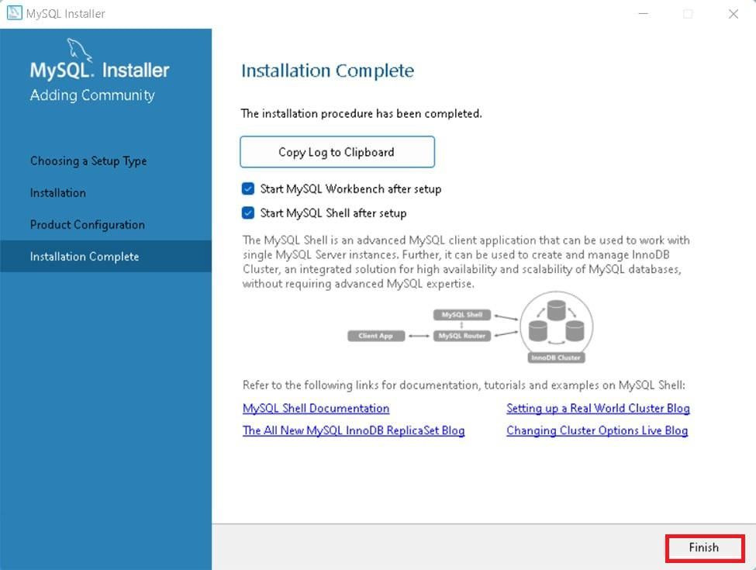

**Step 12: Verify Installation**

To ensure a successful installation of MySQL, open the MySQL Command Line Client or MySQL Workbench, both available in your Start Menu. Log in using the root user credentials you set during installation.